Hel.A.S. Annual Membership Fee Invoice - 2024

Personal Information
Membership Class
Title (Mr., Mrs., Dr., Prof.) : (tick the appropriate box)
Family name: Ordinary
Name: Associate
Middle Initial: Junior
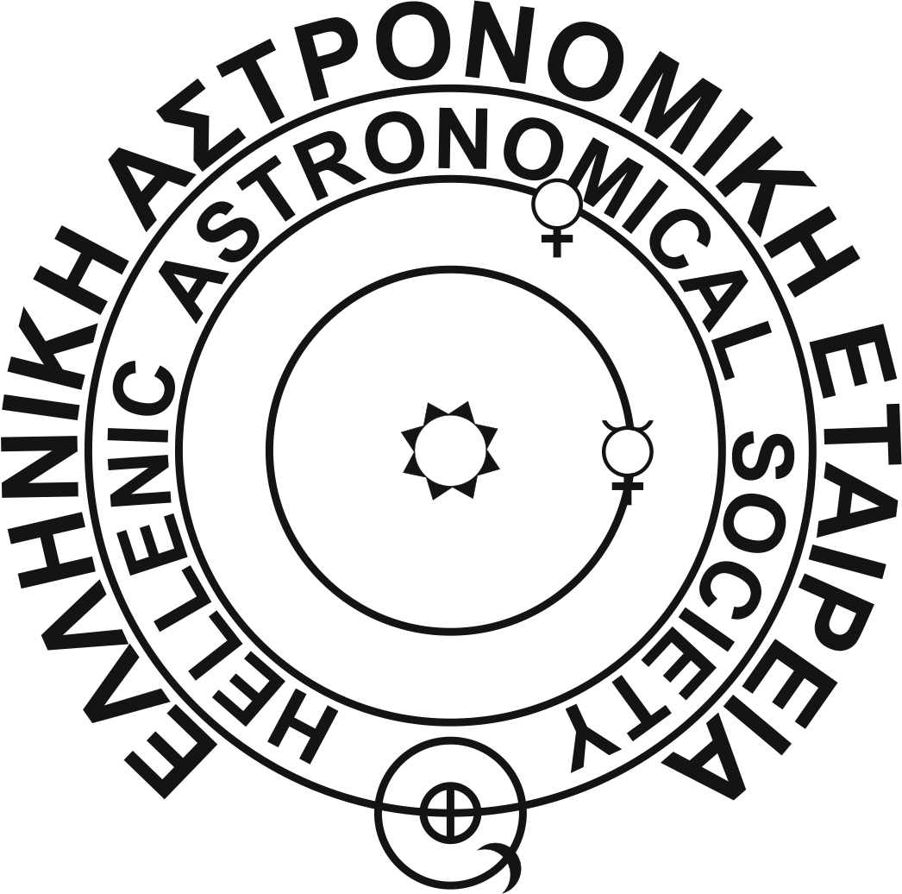
Is your address correct in the online directory of Hel.A.S? Yes No
The directory is available at http://www.helas.gr/members.php
If you selected No above, please complete your address information in the back of this form.

Invoice details
Amount (in Euro)
Membership Fee for 2024 (please tick appropriate boxes):
Ordinary / Associate Junior
Registration fee (if applicable):
Outstanding past membership fees (if uncertain contact the Treasurer):
Total:

Payment Method

Payments can be made by direct deposit or electronic transfer to the bank account of the Society, or using a credit card at the secure link provided bellow. Please complete the information bellow and send the present file along with the copy of the receipt of your payment to the Treasurer.

I have made an electronic transfer or direct deposit of the amount mentioned above to the account of Hel.A.S. Account Details:
Bank: “Τράπεζα Πειραιώς” (“Bank of Piraeus”)
Account Name: “ΕΛΛΗΝΙΚΗ ΑΣΤΡΟΝΟΜΙΚΗ ΕΤΑΙΡΕΙΑ” (¨ELLHN. ASTR. ETAIR.¨)
IBAN number: GR42 017 2039 0005 0390 3372 2178
SWIFT number: PIRBGRAA

I have made a payment using a credit card via the following link:
https://helas.gr/payment.php

Payments in cash can be done only in person. For further details please contact the Treasurer of Hel.A.S. Dr. A. Papaioannou directly by e-mail at: treasurer@helas.gr or by phone at +30-210-3490882.

Return Address Deadline: 31 August 2024

We strongly encourage communication by e-mail with the Treasurer. Please return this form (if necessary) along with the PDF file of the receipt of your payment to: treasurer@helas.gr
You may also send it by post to the address:

The Treasurer of the Hellenic Astronomical Society (Hel.A.S.)
Dr. Athanasios Papaioannou
National Observatory of Athens
Institute for Astronomy, Astrophysics, Space Applications & Remote Sensing
I. Metaxa & V. Pavlou
GR-15236 Penteli
GREECE

Change of Address Information

If your address has changed and it is not displayed correctly in the online directory of Hel.A.S., please provide the following information. This should be the address you wish to have listed in the directory of Hel.A.S., as well as where to receive all correspondence from the Society.

Primary contact / work Address:

Phone : (include country and area code)
Fax : (include country and area code)
e-mail :

You are also encouraged to send any address changes by e-mail to secretary@helas.gr throughout the year as soon as they happen. It helps us to maintain the accuracy of the directory.

Membership Fees

At the recent Annual General Assembly of Hel.A.S., where the level of fees was discussed, it was recommended that the registration fee and the annual membership fee for 2008, remain at the same level as in previous years. The fees are set to:

Fees Ordinary or Associate member Junior member
Registration fee: 15 Euro 8 Euro
Annual membership Fee: 30 Euro 15 Euro

If you are uncertain whether you have outstanding fees from previous years, please contact the Treasurer of Hel.A.S. who can provide details on your financial status towards the Society. Please note that according to Article 32 of the Constitution of Hel.A.S., a member must have paid the current, as well as all outstanding annual membership fees in order to be eligible to vote. Furthermore, according to Article 13 of the Constitution, the Governing Council of the Society may revoke the membership status from an individual if she/he has not paid her/his annual membership fee to the Society for more than 2 years.

Membership Classes

- Ordinary member: Open to any person holding a Ph.D. in Astronomy or closely related field, who is promoting Astronomy through his/her actions.
- Junior member: Open to any person, under 35 years old, studying the science of Astronomy or a closely related field as a postgraduate student.
- Associate member: Open to any person who, through his/her actions, promotes the science of Astronomy, but does not fulfill the requirements of an Ordinary or a Junior member.

For further details about membership classes please refer to Article 5 of the Constitution of Hel.A.S., available online at http://www.helas.gr/const.php

